17.14: On the Kelvin scale, the triple point is 273.16 K, so 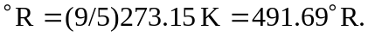 One could also look at Figure 17.7 and note that the Fahrenheit scale extends from 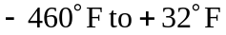 and conclude that the triple point is about 492